A Special Invitation to Join our Caring Community

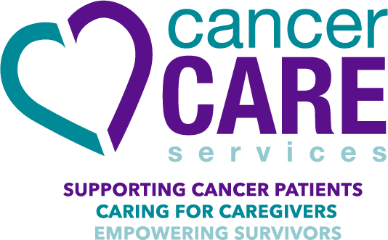
Organizational History and Mission
Cancer Care Services serves thousands of individuals affected by cancer annually in Tarrant County by supporting cancer patients, caring for caregivers and empowering survivors.

Cancer Care Services was founded in 1946 when Fort Worth physicians observed the non-medical challenges that low-income cancer patients faced while undergoing treatment, such as loss of health insurance, lack of transportation to treatment, and the inability to afford prescription medications. In response, a group of compassionate physicians and community leaders created a unique and inventive organization for cancer patients.
In collaboration with JPS, the agency opened the first breast and cervical cancer detection clinic in Tarrant County in the 1970s. Cancer Care Services also paid the salary of the first oncology nurse at JPS Hospital, and hired the first oncology social worker in Tarrant County. Services were offered outside Tarrant County for the first time in April 1997 when Parker County patients were provided assistance with funds raised in Parker County. In September 1998 Hood County residents began receiving services.
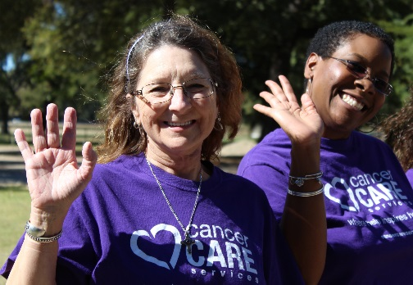
For 72 years, Cancer Care Services has been continuously providing financial and emotional support services to cancer patients, caregivers and survivors in our community. We serve individuals of all ages, cancer types and income levels. All programs and services are provided at no cost to clients.
Cancer Care Services’ collaborative nature and social work navigation model have brought tremendous gains to clients and to the community as a whole. Our programs are an innovative means of optimizing patient access to care, as well as providing support to patients and the health care professionals who deal with systemic challenges on a daily basis. We enable patients to receive the treatment support they need and enhance the community’s capacity to care for and help sustain underserved cancer patients and their families.

Our vision is that EVERYONE who is affected by cancer in our community will access our services, and Cancer Care Services will have the resources to meet their holistic needs.

JOURNEY OF HOPE
The Journey of Hope program encompasses all client programs and services and is budgeted into the general operating budget annually, ensuring long-term sustainability of client programs. The primary focus of The Journey of Hope program features 3 central service areas: Cope, Thrive, and Connect.

- COPE programs include: Health Insurance Assistance, Prescription Co-Pay Assistance, Nutritional Supplements and Dietitian Services, Medical Supplies & Equipment, Counseling/Therapy (including play therapy for children), Skill-Building Workshops, Support Groups, and Case Management/Navigation. Clients must demonstrate financial hardship in order to qualify for financial assistance programs.

- THRIVE programs include: Nutritional Education, Wellness Workshops, Yoga & Meditation, Oncology Massage and Spiritual Support. These free programs are provided to anyone affected by cancer, regardless of income.

- CONNECT programs include: Caregiver & Survivorship Workshops, Day Camp for Children, Art & Music Therapy, Family-Centered Activities, and Social Groups and Events. These free programs are provided to anyone affected by cancer, regardless of income.

Cancer Care Services partners with cancer patients, survivors, and caregivers to improve their self-sufficiency and empower them to care for their overall health. We accomplish this by providing collaborative care planning, financial support for treatment-related needs, as well as coordinating wellness support services that help individuals impacted by cancer improve their long-term well-being.
Client Stories
Supporting Cancer Patients
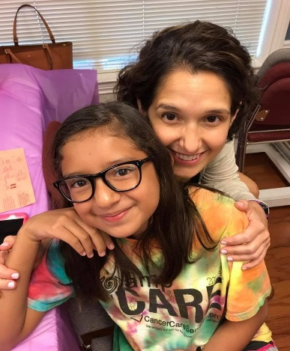
“God must have been talking in your ear.” This was a response to one of our Social Workers connecting with a cancer patient to offer a six month extension on her insurance payment.

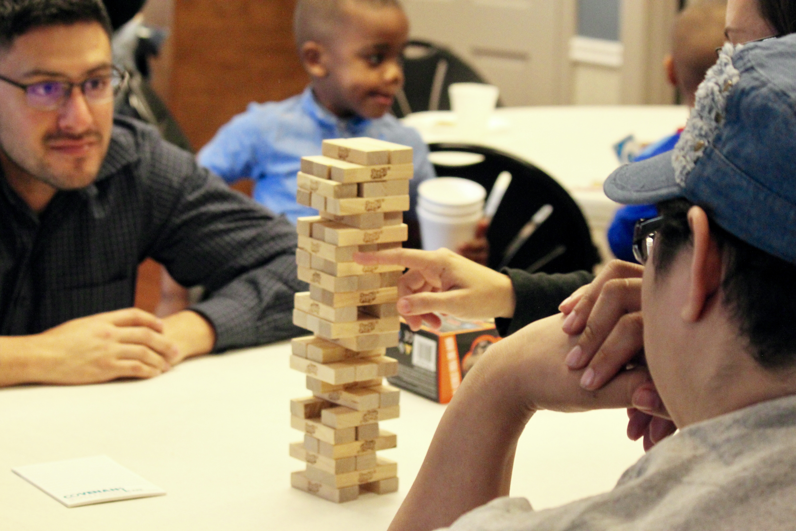
Caring for the Caregiver
Brian’s mom shared that Brian is having a hard time coping with her cancer, and it has been such a fun evening to see him laugh and smile tonight. We needed a break from my cancer, and tonight we got that. He worries about me a lot, and feels like he needs to take care of me. I am glad we got to come tonight.

Numerous studies have shown self-management is an effective model for care that empowers cancer patients and their families to manage diagnosis and treatment-related problems. An important self-management skill is self-sufficiency – the belief in oneself and one’s abilities to complete tasks and accomplish goals. There is evidence that programs that focus on self-management and problem-solving skills increase positive health behaviors, and help individuals cope with the stressful effect of cancer over time.

Community Collaboration
Strategic community collaboration allows us to address gaps in services, reduce program duplicity, and ensure we are responding to the most pressing needs of those at-risk within our community. For example, we partner with Tarrant County Public Health to deliver “Health for Me” a series of self -management workshops for the community that focuses on topics including dealing with anger and pain, healthy eating and health-related problem-solving. We also work with Connecting with Conquerors and Frogs Fighting Cancer to spread the word about Cancer Care Services throughout the community.

Cancer Care Services receives no government funding or insurance reimbursement. We are grateful for our individual and organizational funding partners who enable us to serve the community in our unique and thoughtful way.

Thank you for your partnership! YOU are helping to ensure that each one of our community members impacted by cancer gets the services they deserve and need to Cope, Thrive and Connect.

For more Information:
Deanna Stuart
Senior Development Director
deanna@cancercareservices.org
817.921.0653

