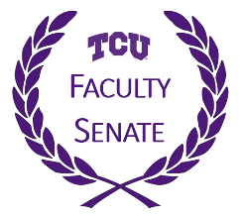
TCU Faculty Senate Meeting
March 5, 2020
3:30 – 5:00 PM
The Chambers, Brown-Lupton University Union, Room 3004

Agenda

Call to Order | Clark Jones
Approval of Minutes February 6, 2019 | Jan Quesada
Announcements:  - Faculty Assembly – March 25th  - Thanksgiving & Fall Break changes | Clark Jones
Remarks from Provost Dahlberg | Provost Dahlberg
Great Colleges to Work for Survey | Cheryl Taylor
Faculty/Staff Annual Campaign | Kristee Bell/Clark Jones
Religious Holidays Policy | Claire Sanders
Vote on UCAC Benefits Package Proposal | Greg Stephens
Vote on Compensation Resolution from FRC | Andrew Ledbetter
Announcement Election of Senators | Pam Frable
Resolution on DEI from FSEC | Sean Atkinson
Closing Remarks and Adjournment | Clark Jones

Faculty Assembly:
- Wednesday, March 25th (Shaddock Auditorium) 3:30-5:00 pm
- Vote on DEI Essential Competency in the Core Curriculum and Constitution & Bylaw changes

New Fall 2020 Dates:
- 2020 Fall Break: October 8th & 9th (Thurs/Fri)
- 2020 Thanksgiving Break: November 23rd – 27th

Documents Distributed:
- Unapproved Minutes
- Faculty Assembly
- FRC Compensation Resolution
- UCAC Narrative & Benefits Proposal
- TCU Religious Observations & Holidays
- Senate Elections Letter
- Statement on DEI from FSEC

