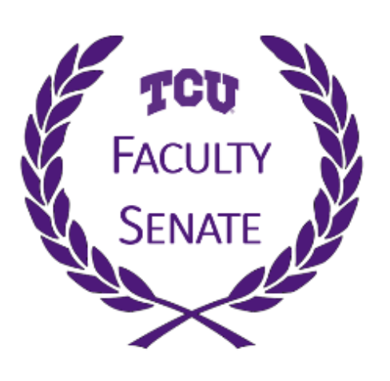
Faculty Senate Meeting
Thursday, October 1, 2020
3:30 – 5:00 PM
Via Zoom
https://tcu.zoom.us/j/91955979799

Agenda

Call to Order | Sean Atkinson
Approval of the Minutes | Sean Atkinson
Remarks from Chancellor Boschini | Chancellor Boschini
Remarks from Provost Dahlberg | Provost Dahlberg
Shared Governance | Sean Atkinson
Core Curriculum Assessment | Ed McNertney
Admissions Update on SAT and ACT | Heath Einstein
Closing Remarks and Adjournment | Sean Atkinson

Upcoming Dates:

Senate Committee Meetings Thursday October 8 OR October 15 at 3:30pm
Next Faculty Senate Meeting Thursday, November 5 at 3:30pm

