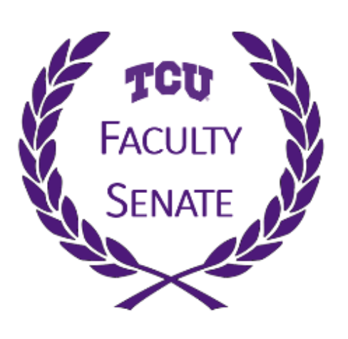
Faculty Senate Meeting
Thursday, April 29, 2021
3:30 – 5:00 PM
Via Zoom
https://tcu.zoom.us/j/91955979799

Agenda

Call to Order | Sean Atkinson | 3:30 PM
Approval of the Minutes | Sean Atkinson | 3:31 PM
Remarks from Chancellor Boschini | Chancellor Boschini | 3:32 PM
Remarks from Provost Dahlberg | Provost Dahlberg | 3:37 PM
Resolution to Welcome the AAUP | Andrew Ledbetter | 3:47 PM
Recommendation on UBAC and UCAC membership | Ted Legatski | 3:57 PM
End of Year Reports from Committees
Faculty Relations | Andrew Ledbetter | 4:02 PM
Academic Excellence | Lisa Bashore | 4:07 PM
University Committees | Ted Legatski | 4:17 PM
Educational Evaluation | Michael Sawey | 4:22 PM
Governance | Pam Frable | 4:27 PM
Student Relations | Phil Esposito | 4:32 PM
Thanks and Welcome | Sean Atkinson | 4:37 PM
Senate Officer Election Results | Sean Atkinson | 4:42 PM
Transfer of the Hot Potato | Joddy Murray | 4:47 PM

